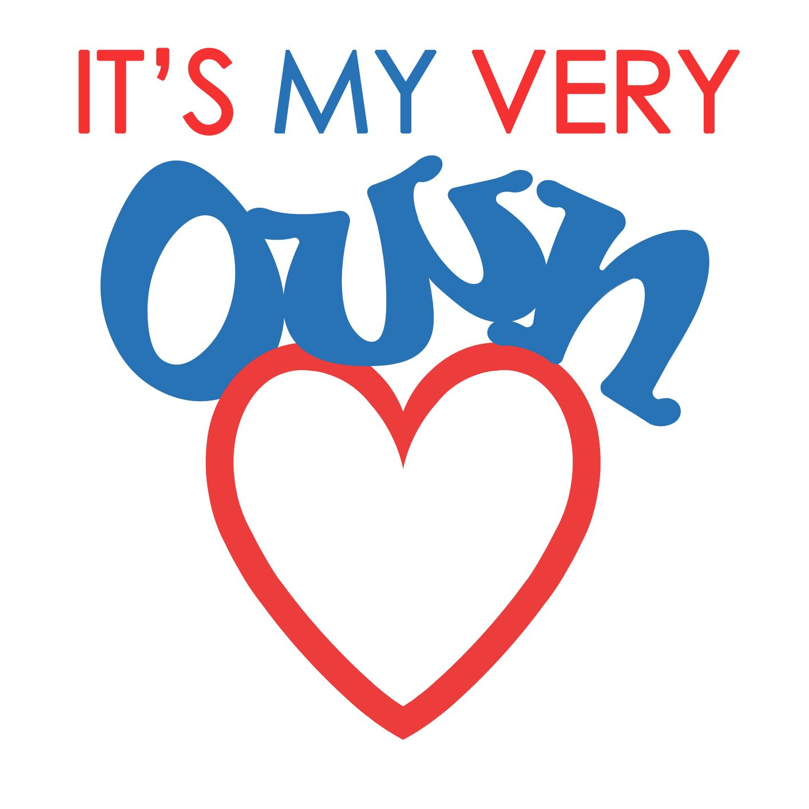

***This quilt was handmade by the   
loving hearts and hands of the Brunswick and Camden   
Seventh-day Adventist Church   
Family and Friends***

**IMVO.ORG**



***This quilt was handmade by the   
loving hearts and hands of the Brunswick and Camden   
Seventh-day Adventist Church   
Family and Friends***

**IMVO.ORG**



***This quilt was handmade by the   
loving hearts and hands of the Brunswick and Camden   
Seventh-day Adventist Church   
Family and Friends***

**IMVO.ORG**



***This quilt was handmade by the   
loving hearts and hands of the Brunswick and Camden   
Seventh-day Adventist Church   
Family and Friends***

**IMVO.ORG**



***This quilt was handmade by the   
loving hearts and hands of the Brunswick and Camden   
Seventh-day Adventist Church   
Family and Friends***

**IMVO.ORG**



***This quilt was handmade by the   
loving hearts and hands of the   
[Your Church Name]   
Seventh-day Adventist Church   
Family and Friends***

**IMVO.ORG**